CSE 461 Homework #4
Yousef Jarrar
(CSE 461 Students only answer 6 questions, extras are bonus points)

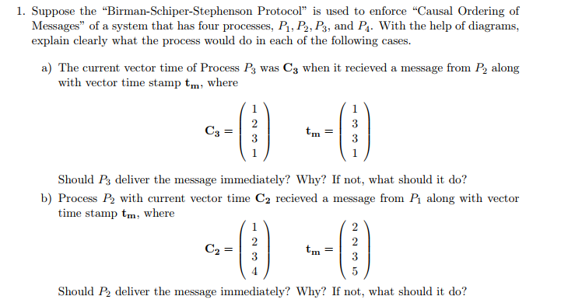
A) P₃ should deliver message immediately: C₃[2] = t_{m}[2] -1 and C₃[k] >= t_{m}[k] (k = 1,3,4)

P1
P4
P3
P2

